**Exercise 6**

**Listening skills**

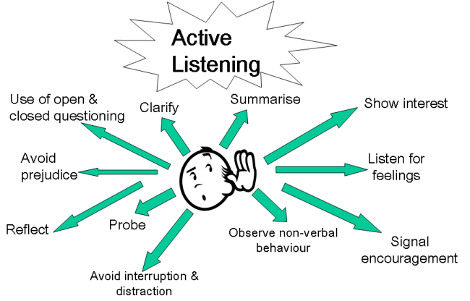

Business benefits of listening to customers and stakeholders

* Improved customer satisfaction
* Improved market share
* More customers and more repeat business
* Clear confirmation of customer specifications and requirements
* Providing the right product at the right time
* Inspiring confidence in the organisation’s ability to meet stakeholder needs and expectations
* Less waste, rework and duplication of effort
* Gain competitive edge
* Customer feedback can lead to innovation and improvement
* Improved staff engagement
* Improved productivity
* Smoother supply chains